Walks for 2026
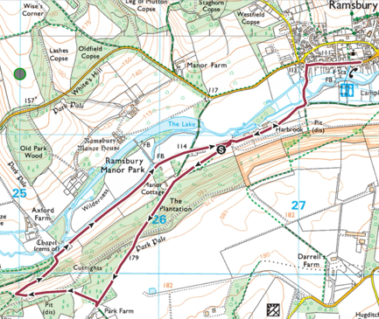
1st February: Axford via River Kennet (4 miles) – 1.5 hours

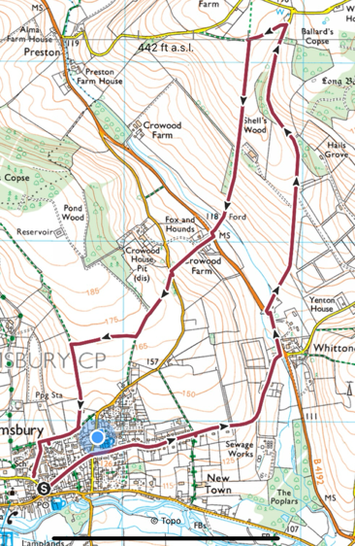
1st March: Whittonditch via Marridge Hill (4 miles) - 1.5 hours

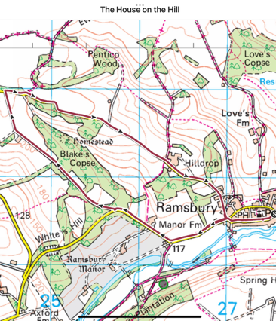
5th April: The House on the Hill (4.5 miles) – 1.45 hours

3rd May: No walk - Boundary Walk

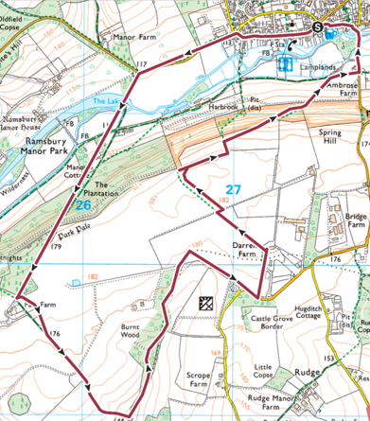
7th June: D-Day (+1) Airfield Walk (5 miles) – 2.15 hours

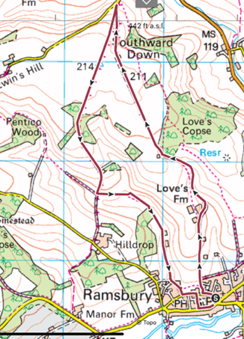
5th July: To Aldbourne (nearly) and Back – 4.5 miles – 1.5 miles

August – No Walk: Summer Break

